Using Free WIFI
Do your children have to do homework online? During the corona crisis, Telenet and Proximus are opening up their networks for children who do not have internet at home. Follow the steps below to make use of this service:

Step 1: check whether there is a Free network near you

You can't use free WiFi everywhere. You can only do so if one of your neighbours is a Telenet/Proximus customer. So you will need to know whether there is free Wi-Fi near you. You can check this with a laptop or a smartphone.

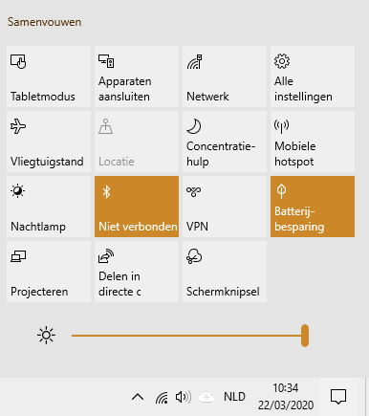
How to check on a computer running Windows 10

Click on the square at the bottom right of the screen
Then click on 'network'.

You will then see a list of Wi-Fi networks. Every network has a name. Look for a network called 'TelenetWiFree' or ‘Proximus Public Wi-Fi’.
Do you see a network called 'TelenetWiFree'?
Then go to step 2 on the page entitled TELENET

Do you see a network called ‘Proximus Public Wi-Fi’?
Then go to step 2 on the page entitled PROXIMUS

You don’t see a network called 'TelenetWiFree' or Proximus Public Wi-Fi’?
Then you cannot take advantage of the offer. Please inform the school.
How to check on a smartphone or tablet
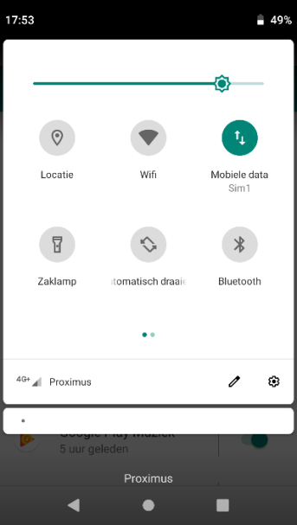
Look for the WiFi icon by swiping down the top of your phone .
Click on the WiFi icon and turn on WiFi.
You can now see all the WiFi networks in your area. Every network has a name. Look for is a network called 'TelenetWiFree' or ‘Proximus Public Wi-Fi’.
Do you see a network called 'TelenetWiFree'?
Then go to step 2 on the page entitled TELENET

Do you see a network called ‘Proximus Public Wi-Fi’?
Then go to step 2 on the page entitled PROXIMUS

You don’t see a network called 'TelenetWiFree' or Proximus Public Wi-Fi’?
Then you cannot take advantage of the offer. Please inform the school.

TELENET

Step 2: connecting the computer to Wi-Free
On a computer RUNNING Windows 10, this is how it works:
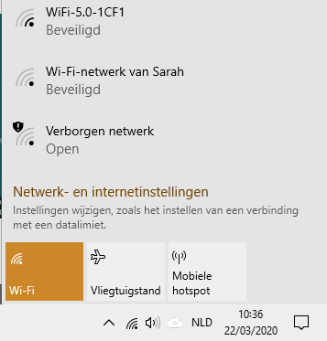

Click on the square at the bottom right of the screen
Then click on 'network'.

You will see this

Click on TelenetWiFree
To log into WiFree you need a username and password. You will get these from school.
Enter your username and password:
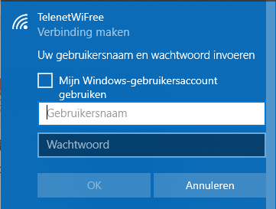

Gebruikersnaam (username):
Wachtwoord (password):

Your laptop will now automatically connect to the Wi-Free network.
This service is free until the end of June. After that you will not be able to access the Internet with Wi-Free .
You cannot connect?
The connection may not be strong enough. Or your neighbor's modem may not be switched on.

Do you need help?
Call Telenet's free helpline
0800/66 720
You can call from Monday to Friday between 9 AM and 4 PM

PROXIMUS

StEp 2: connecting the computer to Public Wi-FI

On a computer RUNNING Windows 10, this is how it works:

Click on square at the bottom right of the screen
Then click on 'network'.

You will see this

Click on Proximus public wi-fi
To log into Public Wi-Fi you need a username and password. You will get these from school.
Enter your username and password:

Gebruikersnaam (username):
Wachtwoord (password):

Your laptop will now automatically connect to the Public Wi-Fi network. This service is free until the schools reopen. After that you will not be able to access the Internet with Public Wi-Fi .
You cannot connect?
The connection may not be strong enough. Or your neighbor's modem may not be switched on.

Do you need help?
Call Proximus’ helpdesk
0800/22 800

